**DS20613 - Assignment 4 – Pull Up/Down Resistor**

**Submitted on 23 October 2020**

**Name:** Theivaprakasham H

**Roll Number:** CB.EN.P2CEN20026

**List of Components**

**Name** **Quantity**  **Component**

U1 1 Arduino Uno R3

D1 1 White LED

D2 1 Red LED

R1

R2

R3

R4 4 10 kΩ Resistor

B1

B2 2 Push Button

**Wire Diagram of Pull up and Pull down Resistor**

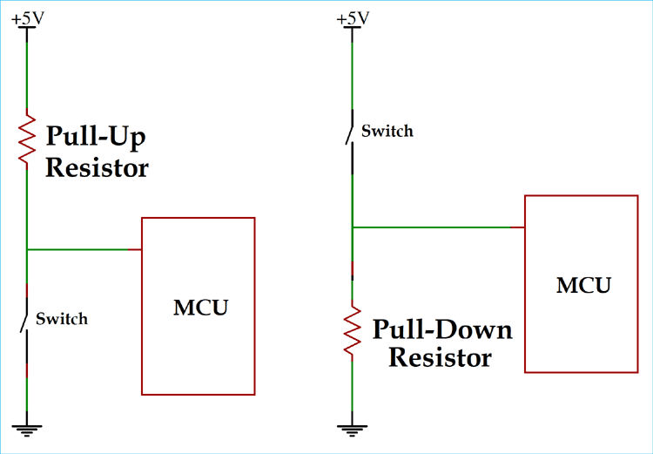

**\*MCU - Micro Controller Unit**

**Breadboard view:**

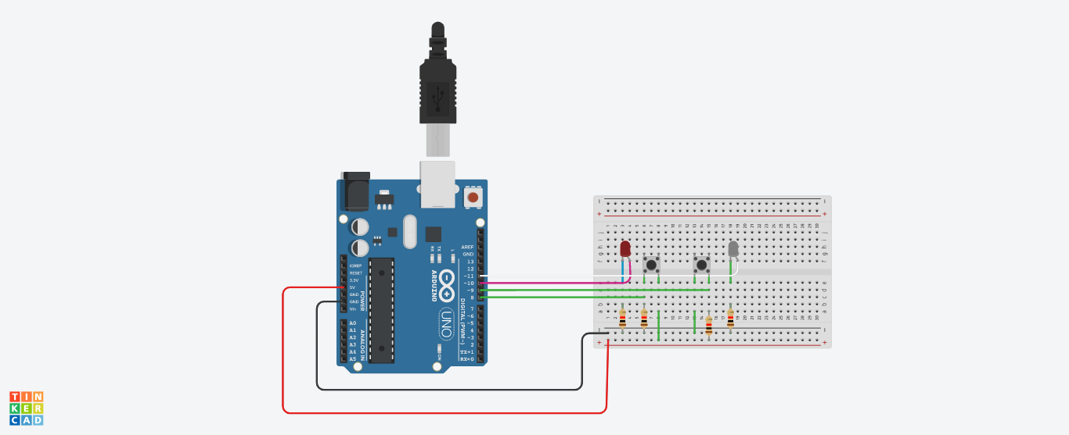

**Live implementation view**

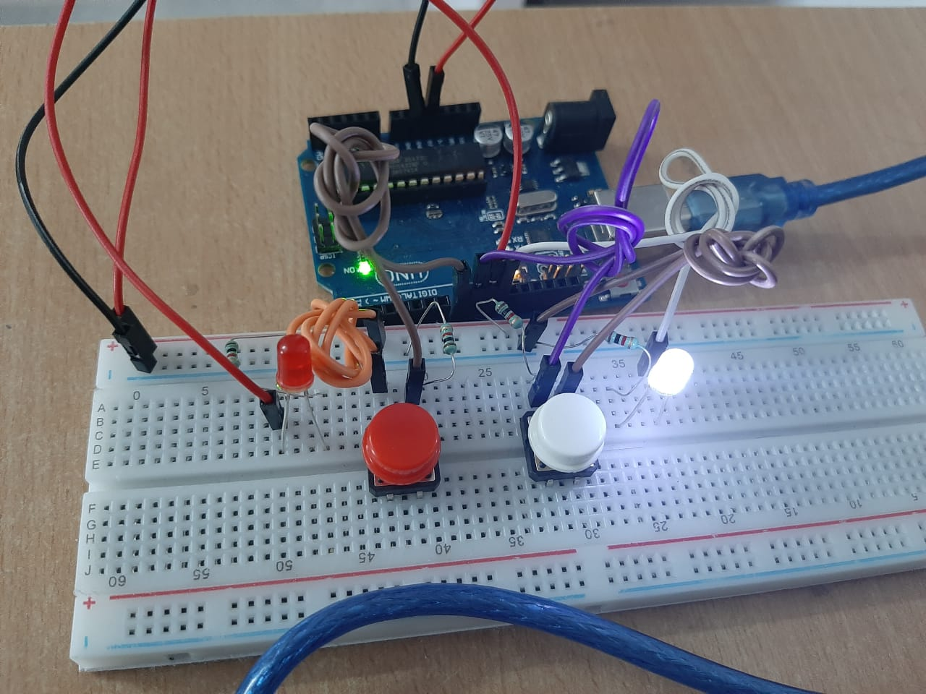

**Pull Up Mode:** In Pull-up configuration, the power source(5V) is connected to the resistor followed by the Digital INPUT pin9 which make the Digital Input value always HIGH. A switch is connected from Digital pin 9 to the ground. Whenever the White Switch is pressed, the voltage at the Digital INPUT Pin 9 will go low as the pin is gets shorted to Ground (0V).

In this experiment, we will read the status of Digital INPUT pin 9 and accordingly Power ON/OFF a White LED connected to Digital INPUT pin 11.

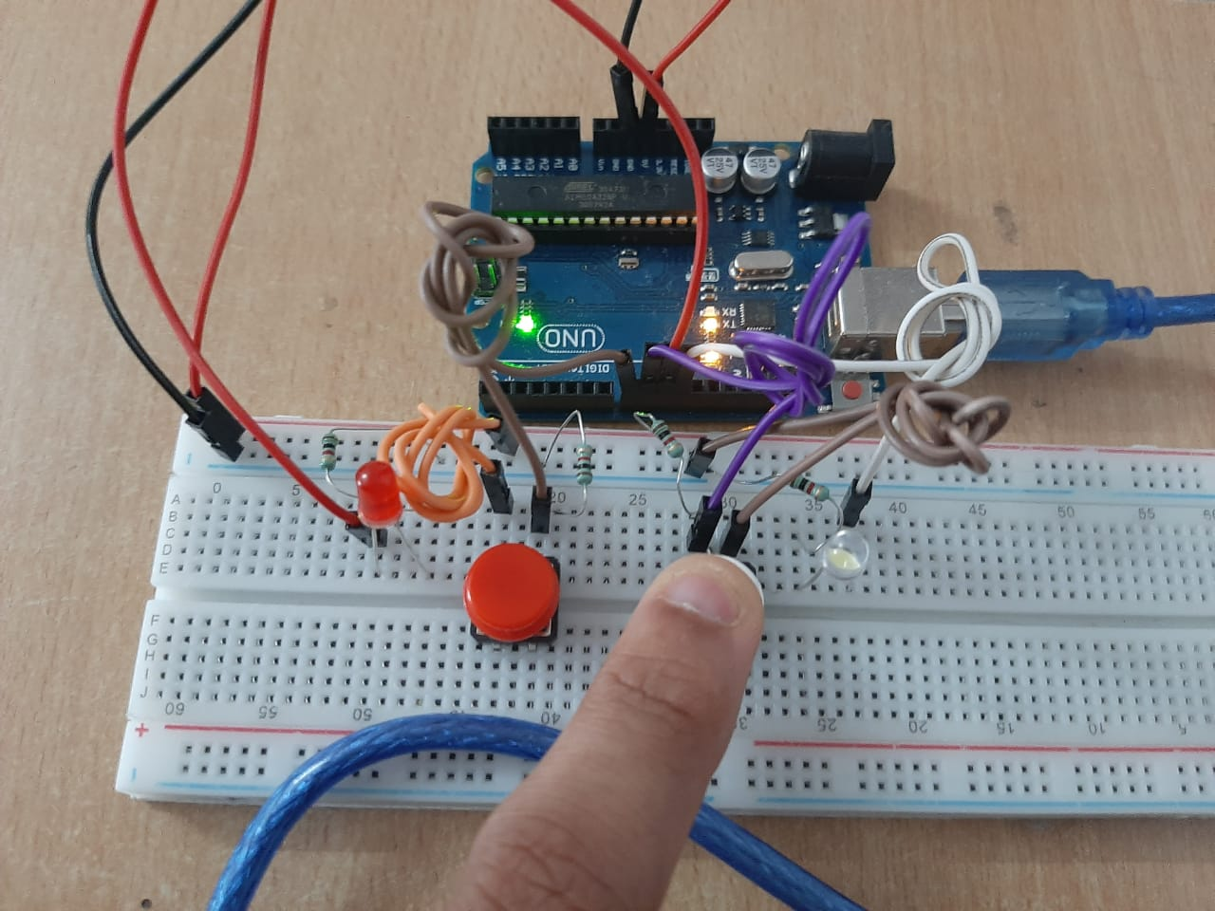

**Serial Ouptut:**

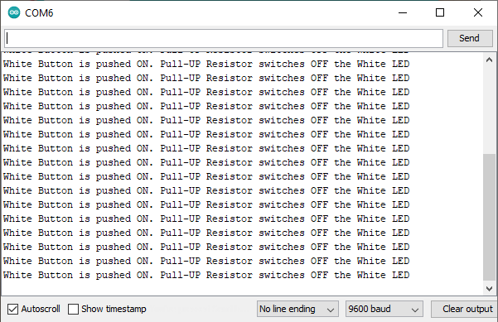

**Pull Down Mode:** In Pull-down configuration, the power source(5V) is connected to the switch followed by the Digital INPUT pin8 which make the Digital Input value always LOW. A resistor is connected from Digital pin 8 to the ground to maintain a reference voltage of 0V in the Digital Pin 8. Whenever the Red Switch is pressed, the voltage at the Digital INPUT Pin 8 will be HIGH as the power source(5V) gets shorted to Digital INPUT Pin 8.

In this experiment, we will read the status of Digital INPUT pin 8 and accordingly Power ON/OFF a RED LED connected to Digital INPUT pin 10.

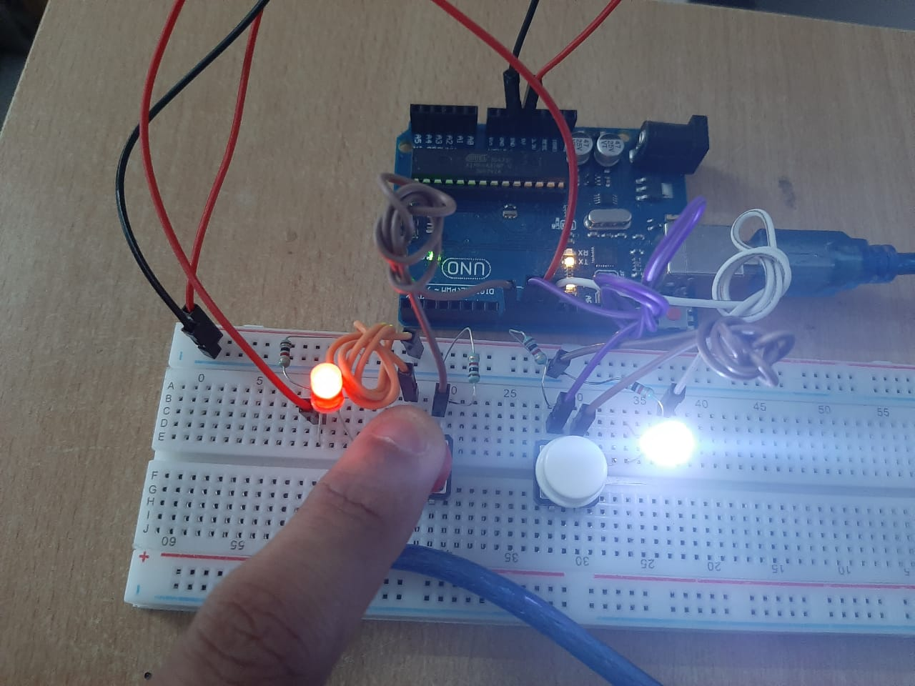

**Serial Ouptut:**

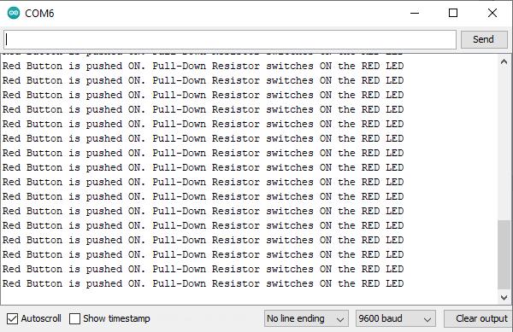

**Code:**

/*

@author: Theivaprakasham H

@title: Pull Up and Pull Down Resistors with Switch

*/

**// Initializing two variables to store the state of the buttons**

int buttonState1, buttonState2;

void setup() {

**//start serial connection**

Serial.begin(9600);

**// Setting button1 = D8(Input) ; button2 = D9(Input); RedLed = D10(Output); WhiteLed = D11(Output);**

DDRB = B00001100;

}

void loop() {

**// Read the state of the pushbutton value:**

buttonState1 = PINB & B00000001; **//performing AND operation to PINB to extract D8 value**

buttonState2 = PINB & B00000010; **//performing AND operation to PINB to extract D9 value**

**// Checking the status of Button1**

if (buttonState1 == B00000001) { PORTB = PORTB | B00000100; **// turn on Red Led(D10)**

Serial.println("Red Button is pushed ON. Pull-Down Resistor switches ON the RED LED");

} else {

PORTB = PORTB & B11111011; **// turn RED LED off**

}

**// Checking the status of Button2**

if (buttonState2 == B00000010) { PORTB = PORTB | B00001000; **// turn ON White Led(D11)**

} else {

PORTB = PORTB & B11110111; **// turn WHITE LED off**

Serial.println("White Button is pushed ON. Pull-UP Resistor switches OFF the White LED");

}

}